Answer 4
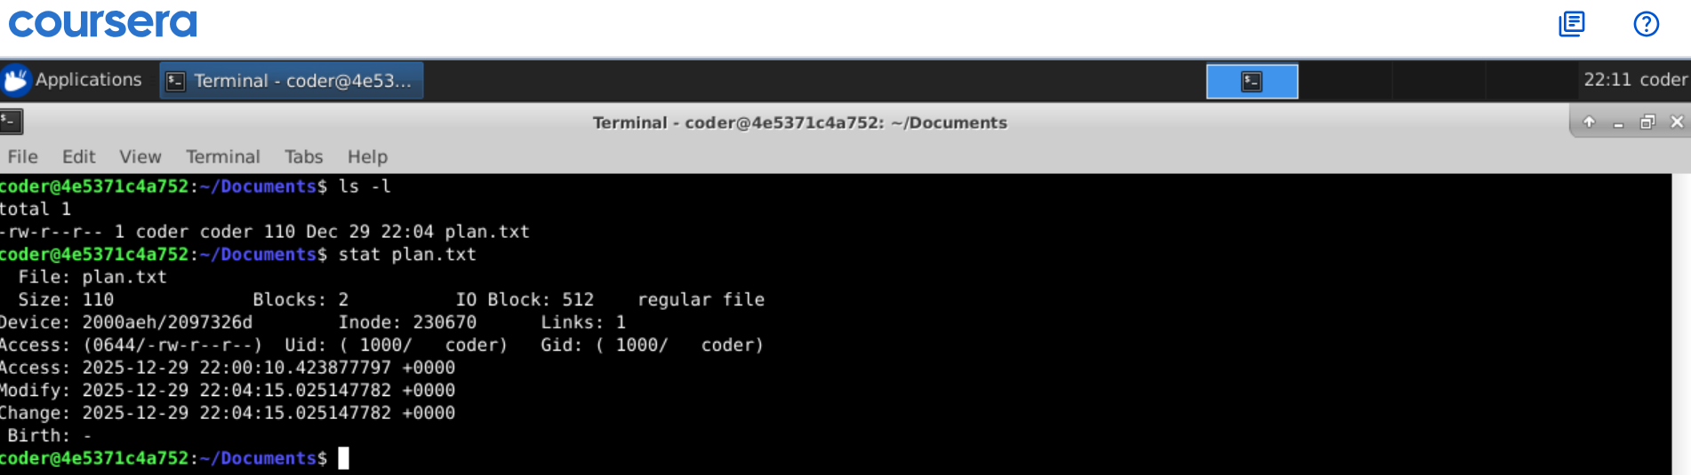
Explanation: This can be done by many ways but I will explain 2 commands ls -l will show username and all the permission. Another command is stat with file name will show all info regarding file includes many things,

